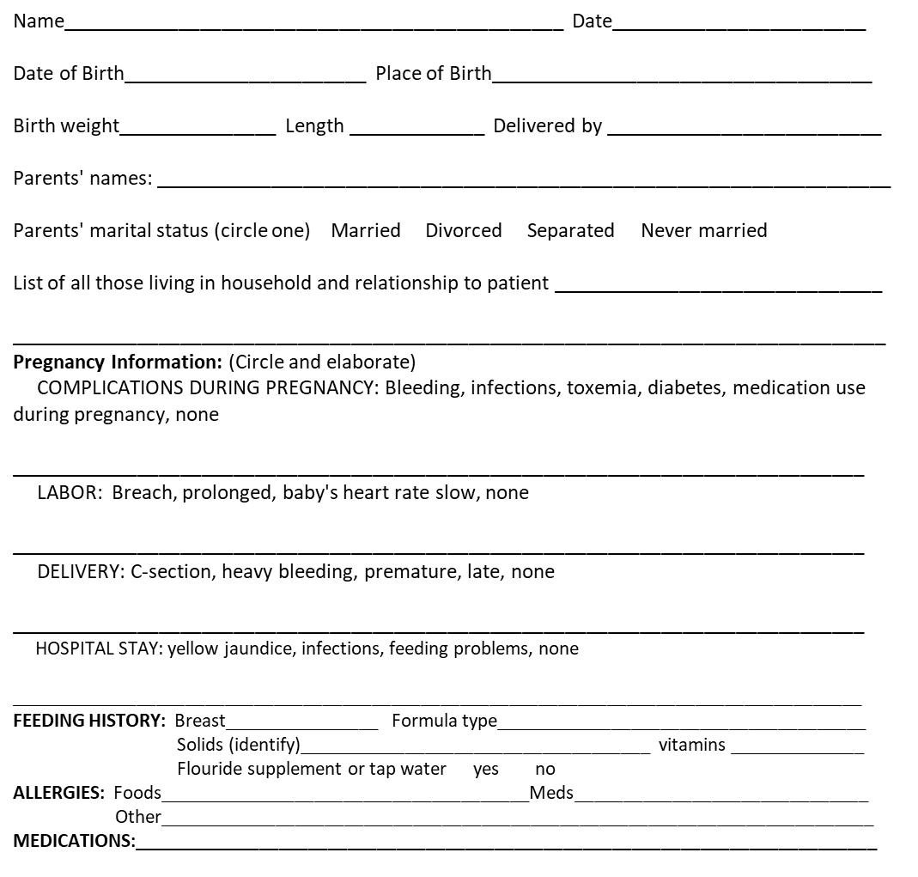
SERIOUS INJURIES OR ACCIDENTS DATES:

Immunizations and Dates:
 | #1 | #2 | #3 | #4 | #5
DTaP
Polio
Measles, Mumps, Rubella (MMR) ___________________________________TB Test________________________
BCG____________________ Other (Typhoid, cholera, small pox) _______________________________________
DEVELOPMENTAL: Age child: Sat up__________ Crawled ___________Walked __________
Toilet Trained __________ Talked in phrases ___________
DAYCARE: Home based Center based
EXPOSURE TO CIGARETTE SMOKE: Yes No
FIREARMS IN HOME: Yes No
REVIEW OF SYSTEMS:
Does your child have, or has he/she ever had: (circle yes or no)
INFECTIOUS DISEASE GASTROINTESTIONAL
Chicken Pox Yes No Frequent abdominal pain Yes No
if yes when: ___________________ Constipation Yes No
HIV/AIDS Yes No
Sexually transmitted disease Yes No GENITOURINARY
Bladder or kidney infection Yes No
ENT Bed wetting (after 5 yrs old) Yes No
Frequent ear infections Yes No
Problems with hearing or ears Yes No ENDOCRINE
Thyroid or other endocrine problems Yes No
ALLERGIES Diabetes Yes No
Food or environment Yes No
SKIN
EYES any chronic or recurrent skin problem Yes No
Problem with eyes or vision Yes No (acne, eczema, etc.)
RESPIRATORY NEUROLOGICAL
Asthma Yes No Frequent headaches Yes No
Frequent bronchitis or pneumonia Yes No Convulsions or other neurological Yes No
Recurrent croup Yes No Concussion Yes No
Tuberculosis or positive TB skin test Yes No PSYCHIATRIC
Other chronic or serious lung disease Yes No Behavior disorder (ADHA, ODD) Yes No
Emotional disorder or suicide attempt Yes No
CARDIAC Psychiatric disorder Yes No
High Blood Pressure Yes No Use of alcohol or drugs Yes No
High Cholesterol Yes No
Heart murmur Yes No GENITOURINARY
Congenital or acquired heart defect Yes No (for girls) has she started menstrual period
Yes No
HEMOTOLOGY (for girls) any difficulties with menstrual period
Yes No
Anemia or bleeding problem Yes No
Blood transfusion Yes No
Cancer Yes No

